Incident Report Form

This form is for either:

* the initial reporting of an incident or allegation that may then require completion of the reportable incident notification form for the NDIS
* or reporting and incident or allegation or disclosure that is not deemed reportable but still needs to be recorded, investigated and acted upon.

# Part A:

|  |  |  |  |  |
| --- | --- | --- | --- | --- |
| Name of the NDIS participant affected by the incident | | | | |
| Title: | Surname: | | Given Name(s): | |
| Address: | | | Phone: | |
| Date of Birth | | | Email | |
| Next of Kin: | Surname: | | Given Name: | |
| Incident (select applicable) | | | | |
| Acts, omissions, events occurring in  relation to providing supports | |  | Have or could have caused harm |  |
| Acts by person with a disability | |  | Have caused serious harm or risk of harm to another person |  |
| Incident Details | | | | |
| Date of, or disclosure of, event: | | | Time: | |
| Location | | | | |
| Describe the incident  Provide details of what happened, include tasks/ equipment/ tools/ people involved, operational issues. Include the impact on or harm caused to any person with disability affected by the incident, including actions to support or assist persons including independent advocates, to ensure their health, safety and wellbeing. | | | | |

## Nature of Injury

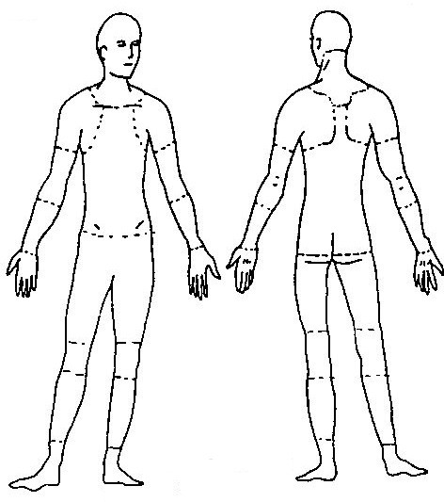

|  |  |  |  |
| --- | --- | --- | --- |
| Contusion/crush | Burn | Dislocation | Amputation |
| Laceration/ open wound | Superficial injury | Foreign body | Internal Injury |
| Concussion | Sprain/ stain | Fracture | Dermatitis |

Location of Injury

|  |  |  |
| --- | --- | --- |
| Head/ face | Eye | Internal organs |
| Hand/fingers | Shoulder/ arms | Trunk (other than back) |
| Hip/ leg | Foot/ toes | Back |
| Other: | | |

Shade on the diagram the location of the injury.

## Was participant transferred to a doctor/hospital? Yes ☐ No ☐

(If yes, give details):

|  |  |
| --- | --- |
| Immediate actions taken to make situation safe: | |
| Witness (for Notifiable incident attach signed witness statement or letters of complaint) | |
| Witness Name: | Witness Phone: |
| Email: | |
| Reportable incident to NDIS / Worksafe / Other  Date of contact: | |

**Please email to julie@ safeactions.com.au**